Chapter 12, Solution 20.

Using Fig. 12.51, design a problem to help other students to better understand balanced delta-delta connected circuits.

Although there are many ways to solve this problem, this is an example based on the same kind of problem asked in the third edition.

Problem

Refer to the Δ-Δ circuit in Fig. 12.51. Find the line and phase currents. Assume that the load impedance is 12 + j9Ω per phase.

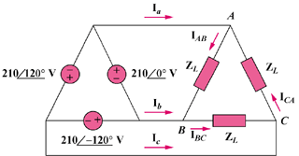

Figure 12.51

Solution

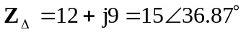

The phase currents are
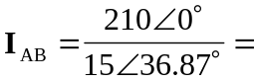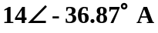
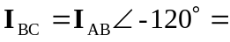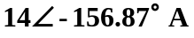
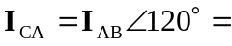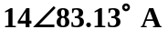

The line currents are
